***Physics notes:***

***Topic 2 – Electricity:***

**Investigating Resistance:**

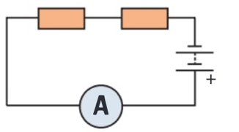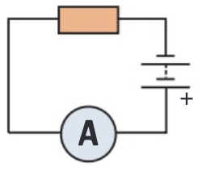**Series Circuit - Method:**

1. First, you’ll need at least four identical resistors
2. Then build the circuit shown on the right using ones of the resistors
   1. Make a note of the potential difference of the battery
3. Measure the current through the circuit using the ammeter
   1. Use this to calculate the resistance of the circuit using r = v / I
4. Add another resistor, in series with the first
5. Again, measure the current through the circuit
   1. Use this and the potential difference to calculate resistance
6. Repeat steps 4 and 5 until you’ve added all 4 resistors
7. Plot a graph of the number of resistors gains the total resistance

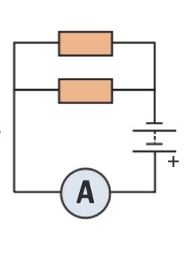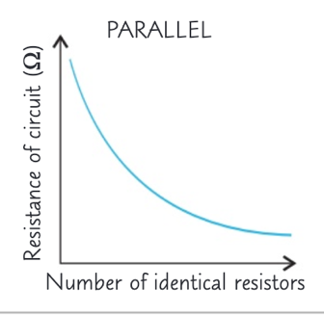**Parallel Circuit – Method:**

1. Using the same equipment as before, build the initial circuit again
2. Measure the total current through the circuit and calculate resistance using r = v / I
3. Next, add another resistor in parallel with the first
4. Measure the total current through the circuit and calculate resistance
5. Repeat steps 3 and 4 until you’ve added all of your resistors
6. Plot a graph of the number of resistors in the circuit against the total resistance

**Analysing the results:**

* **You should find that adding resistors in a series circuit increases the total resistance of the circuit**
  + **And also decreases the total current**
* **When you add resistors in a parallel circuit, the total resistance through the circuit decreases**
  + **So the current decreases**